Instructions for Running the Compile Time Program

By Matthew Le Nepveu

# Disclaimer

The following document is aimed to assist users in obtaining compiling time data from the Unity console. Before running the project, the user should make sure they have all of these programs/utilities, as they are required to run the program:

* Windows 10 Operating System.
* Unity 2019.1.10f1 or later versions.
* Unity Hub.
* MonoDevelop or Visual Studio (to edit the code).

# How to Download

The Software Development 4 code can be downloaded as a zip file in one of two ways:

1. Download the program using this link by clicking the “Download ZIP” option after clicking the “Clone or download” option: <https://github.com/mattylenepveu/SD4ProgramCode>
2. Downloading the zip file directly from the submission page for “Assessment Task 5” on eLearn.

Once the zip file is downloaded, extract the folder by right clicking on the folder and clicking the “Extract All…” option. From there, the files can be extracted by clicking the “Browse…” button and selecting any destination on your computer. This should extract the project from the zip file and onto your computer.

# Opening the Project

For users to edit the main project and retrieve compile times from the Unity editor, the editor can be opened via one of two ways:

1. Opening “Unity Hub” and clicking the “Add” button to add the project. Once the file browser is open, go to the project location and select the folder “SD4ProgramCode”. Make sure that to **select Unity Version 2019.1.10f1 or later** is selected in the drop down list.
2. Opening one of the three project scenes by following this directory from the base project folder downloaded: “./SD4ProgramCode/Assets/Scenes/TestScene”. Again, make sure that **Unity Version 2019.1.10f1 or later** is installed before opening, otherwise it may cause errors.

# Editing the Function Variables and Toggling the Functions On

Once the Unity scene is opened, click on the “Compile Time Tester” component in the hierarchy on the left. This should allow the inspector to be displayed on the right hand side of the screen.

*Figure 1: A screenshot of the main project with an arrow showing where the inspector should be located.*

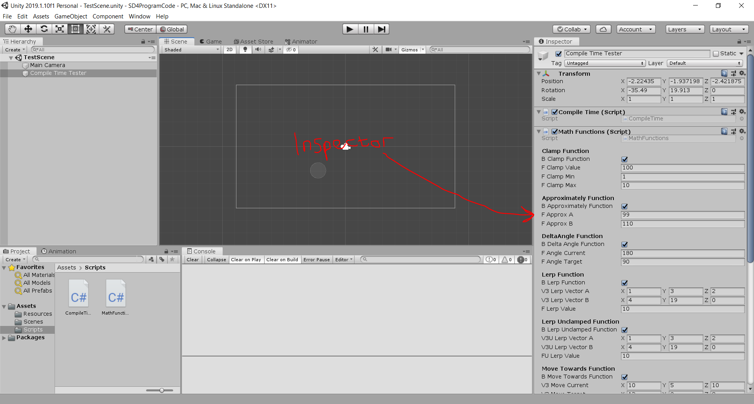

Under the “Math Functions” script component in the inspector, there are ten sections for the ten functions that can be compiled in the Unity editor. Toggling them on or off can simply be done by ticking the first Boolean under each section (eg. If the user wishes to compile the clamp function, tick the checkbox next to the “B Clamp Function” variable in the inspector). The variables can be changed to any decimal or integer number, however they must not be left blank.

# Printing the Compile Times

Before following any of these steps, make sure that the checkbox next to “Compile Time” script component is ticked, otherwise the program **will not compile** and print anything to the text document.

After double-checking that this checkbox is ticked, print the compile times to both the console and text document found in the “Resources” folder, open either one of the two scripts located in the “Scripts” folder by double clicking one of these files:

* CompileTime.cs
* MathFunctions.cs

From there, make any change to the script by making **no change to the code itself** (the change could be as simple as pressing space after a line of code. After that, click “Ctrl + S” to save the changes to the document (or click “Yes” in the dialog box that pops up after pressing the red X at the top right of the program).

Re-open Unity again and make sure that the console is opened at the bottom of the page. There should be a message saying “Compile Started…” in Unity’s console log. This means that Unity is compiling all the scripts and variables ticked from the inspector. The compile might take a while initially however after a little while, another message in the console should pop up with a message like at the bottom of this screenshot:

*Figure 2: Shows the messages that should be shown after compiling.*

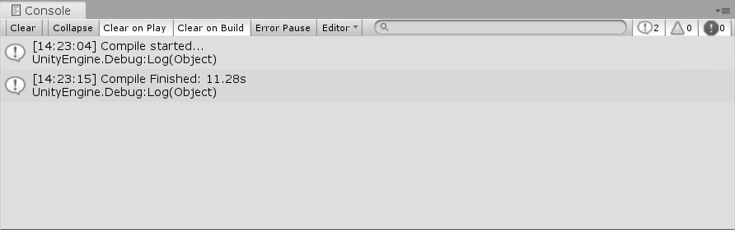

Of course, the number will be different each time and may be a number above ten seconds on the first test, but the number should stay between 2.5 seconds and five seconds consistently for following tests. If the user opens the “data.txt” document in the “Resources” folder, the number printed out to the console should be at the bottom of the document just like in this screenshot:

*Figure 3: Displays the compile time printed out to the text document after Unity compiles.*

